Project Design Phase-II
Data Flow Diagram & User Stories

Date | 19 February 2026
Team ID | LTVIP2026TMIDS80093
Project Name | Prosperity Prognosticator: Machine Learning for Startup Success Prediction
Maximum Marks | 4 Marks

Data Flow Diagram
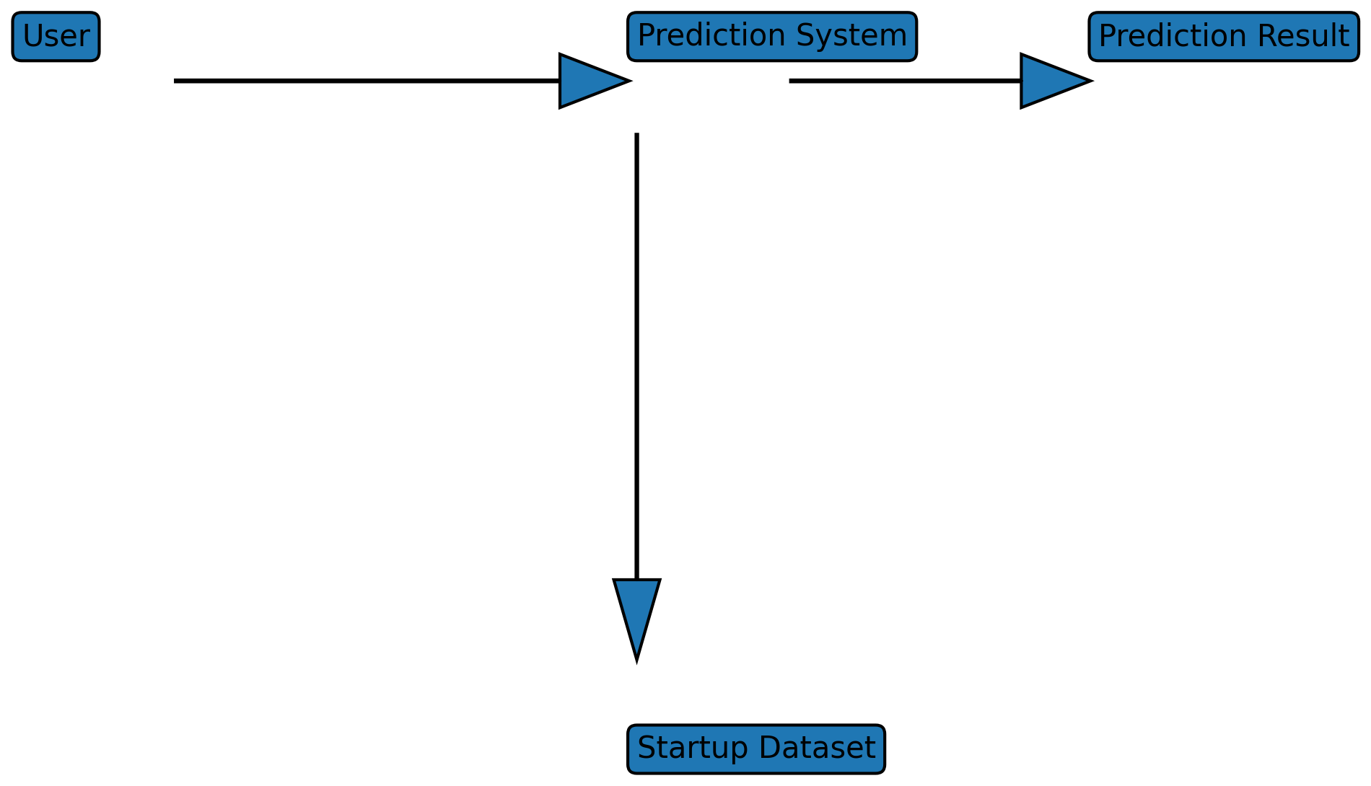

User Stories
User | User Story | Priority
Investor | Predict startup success before investing | High
Entrepreneur | Analyze startup performance | High
Business Analyst | Study startup growth trends | Medium

